Menu for សួនកំសាន្ត Sunshine Show World, this menu has four option for its user to use,

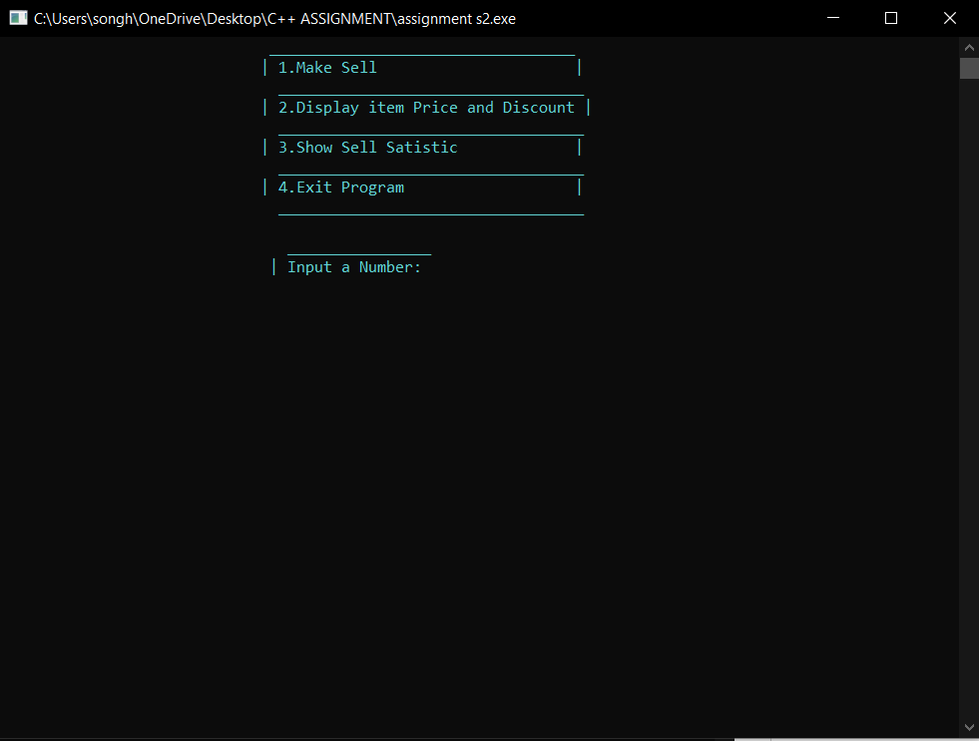Those option are :

**Option 1 (Make Sell )**



This option allow user to

* Count the amount of Visitor that are visiting
* Ask visitor if they want Glove or not
* Ask user their age depend on the amount of visitor
* Once each input has been finished the program will print the receipt

Here's an example of what happens when option one (Make sell) is used.

Enter “1” to use option one

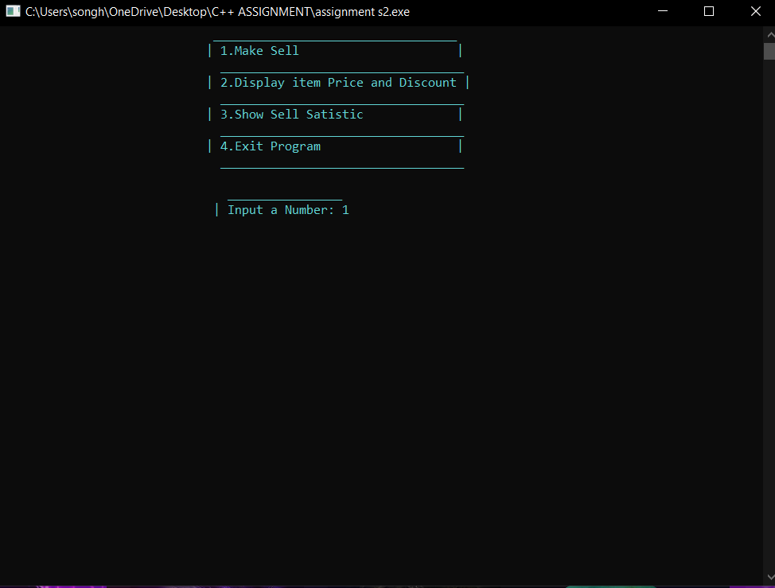

The program will ask the user to enter the number of visitors.

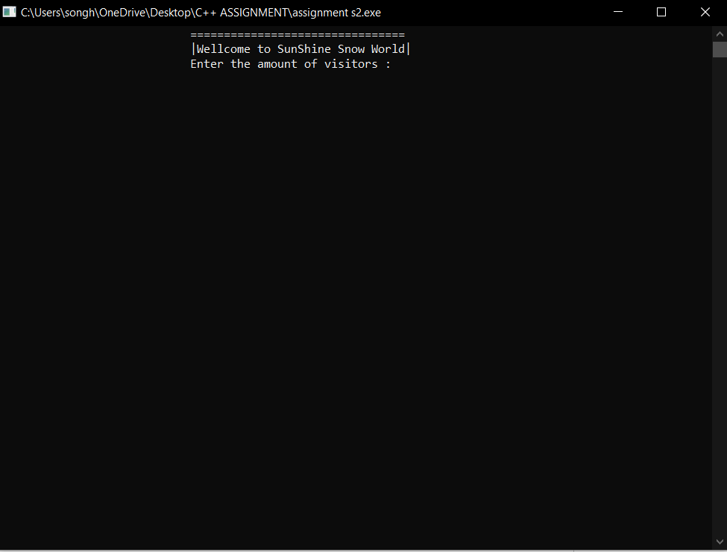

Input = 5 , after input of visitor the program will ask user if the visitor want glove or not.

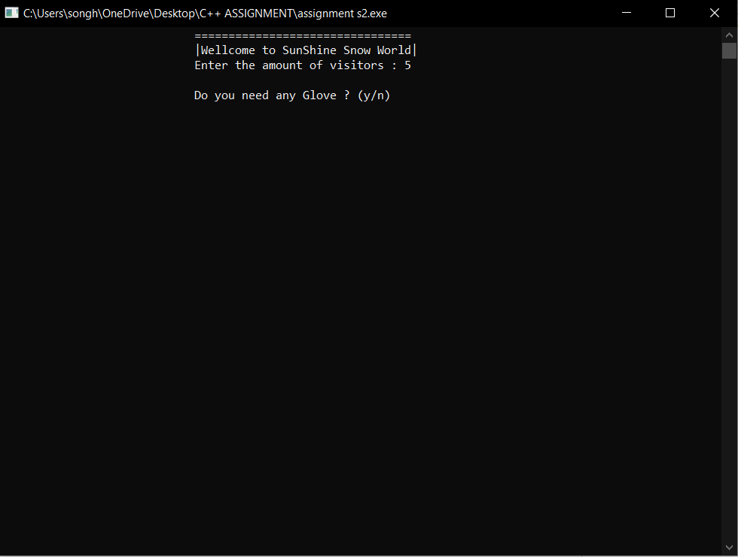

There’s 2 option for user **y** = yes and **n** = no

If user enter **n** = no,

mean visitor won’t be needing any glove then program will print the amount of glove = 0

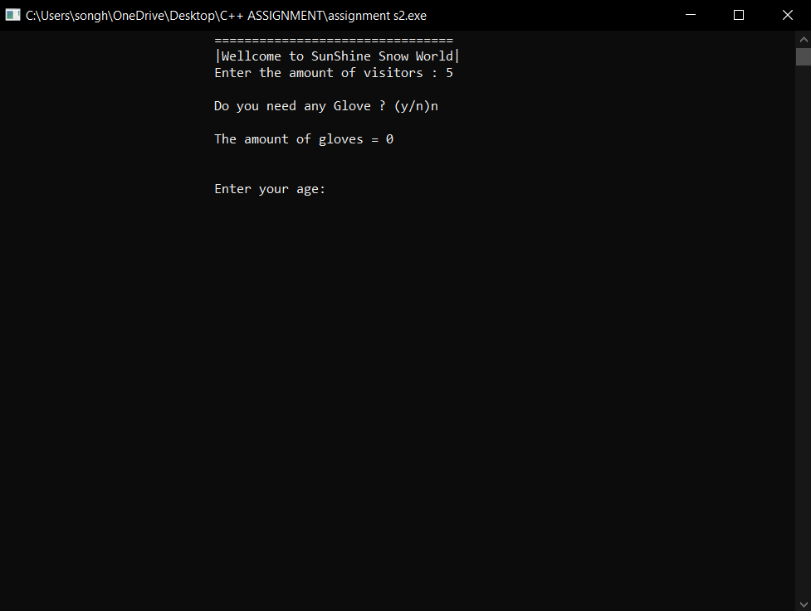

If user enter **y** = yes, it indicates that the visitor wants a glove and program will ask how much glove does visitor want ?

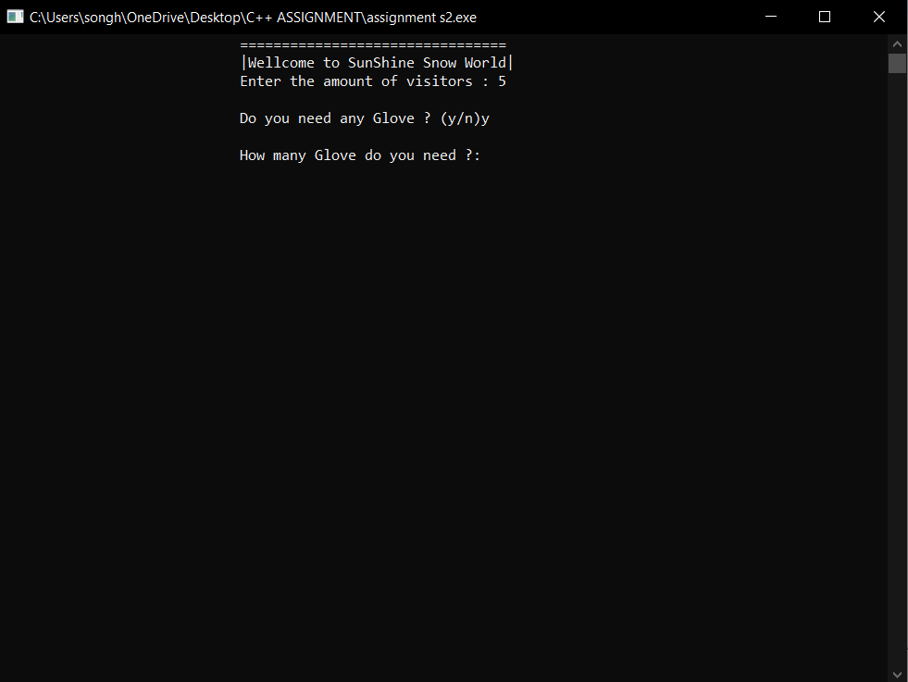

If input of the quantity of glove is 5 then the program will print the amount of glove and after that it will ask user to put each visitor age

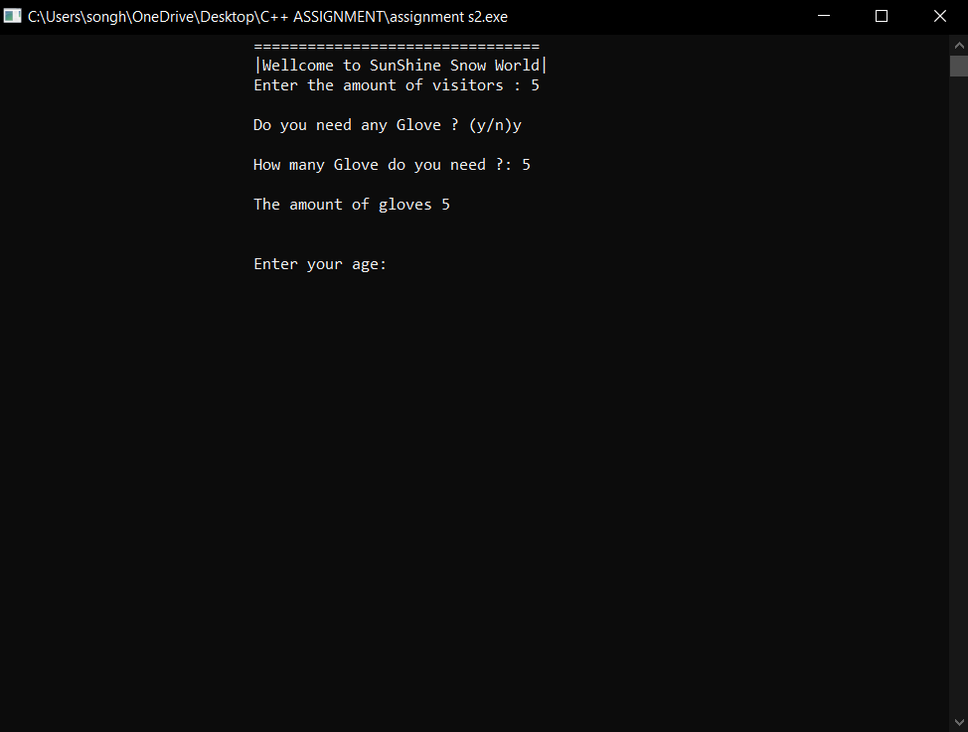

The ticket price for each person will print after their age has been entered.

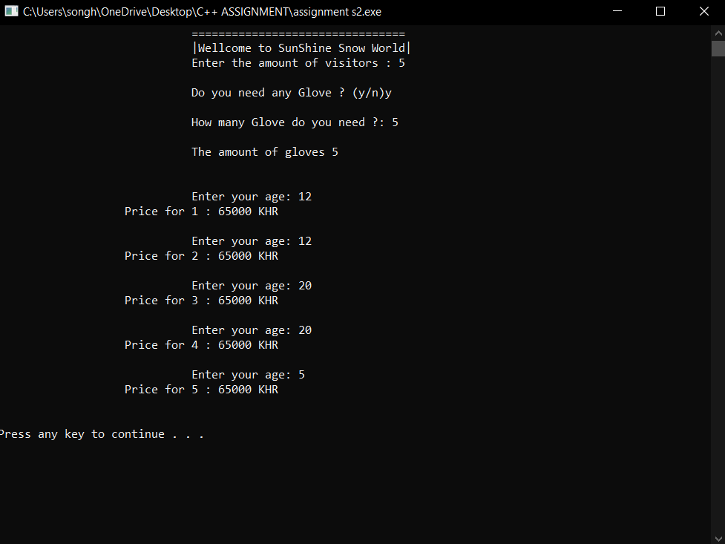

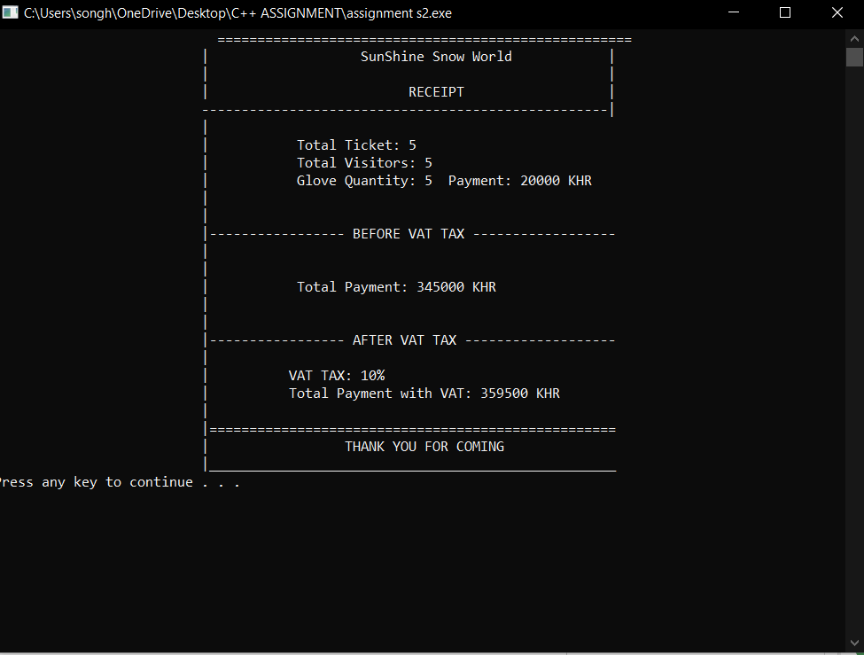The program will print a receipt once all input has been finished.

**For Option 2 (Display item Price and Discount )**

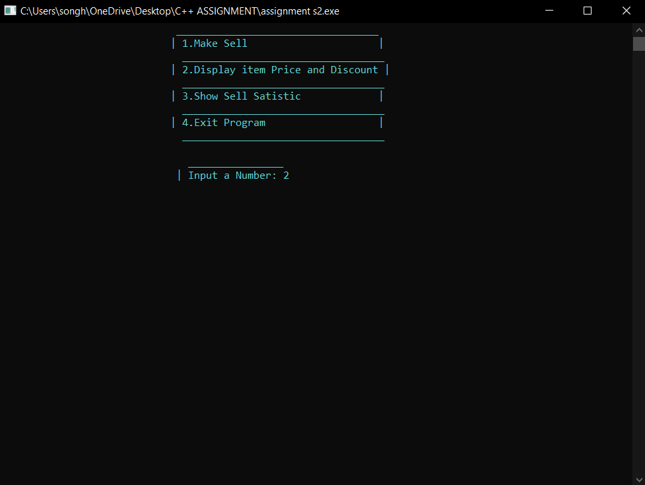The input has to be 2

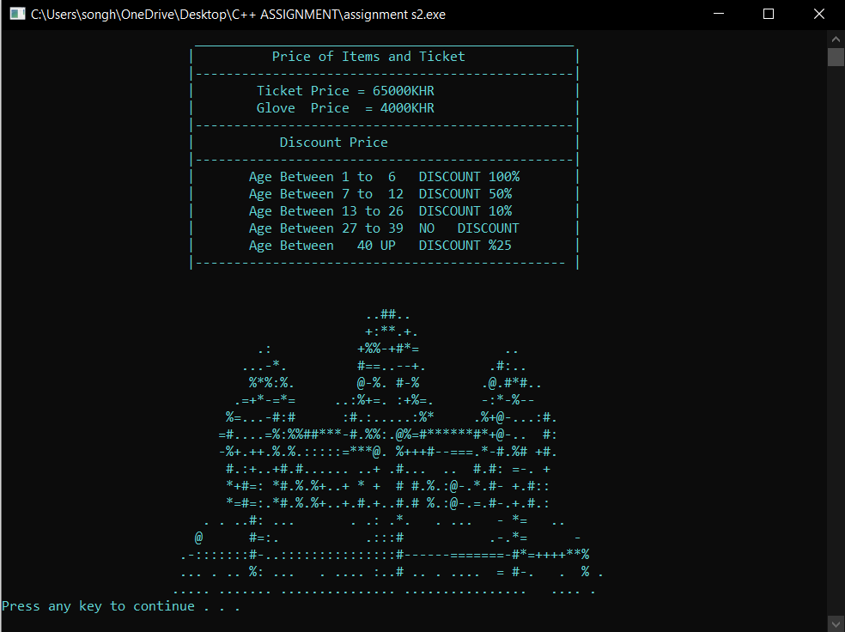After the user selects option 2, the application will print out a table of prices and discount prices.

*Please keep in mind that the discount pricing only valid for a maximum of three guests.

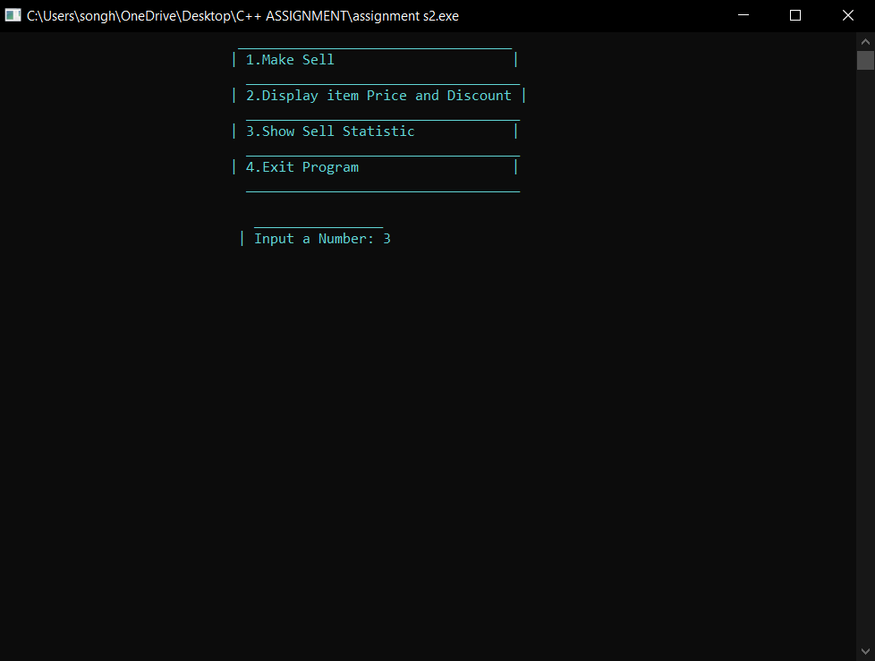**As for Option 3 (Show Sell Satistic )**

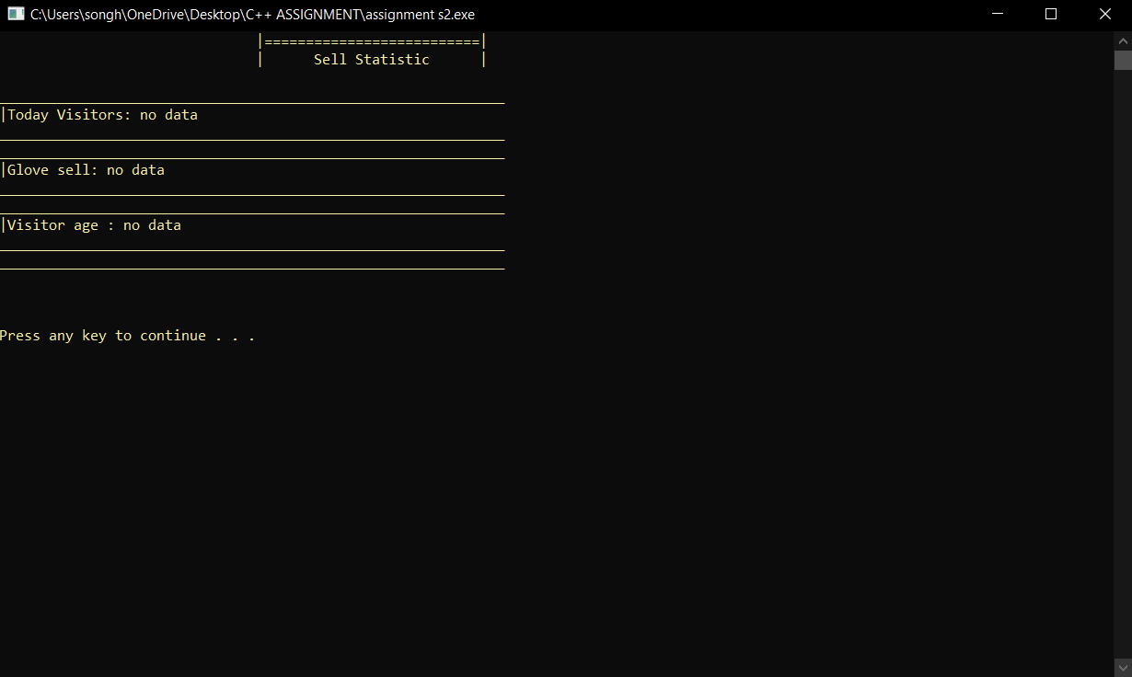This option show the statistic of (Make Sell ) option 1, if option isn’t used yet the option 3 (Show Sell Statistic ) will print out “no data”

But if option 1 (Make Sell) has already been used option 3 (Show Sell Statistic) will show the amount of

* Visitor
* Glove that visitor bought
* And the visitor age

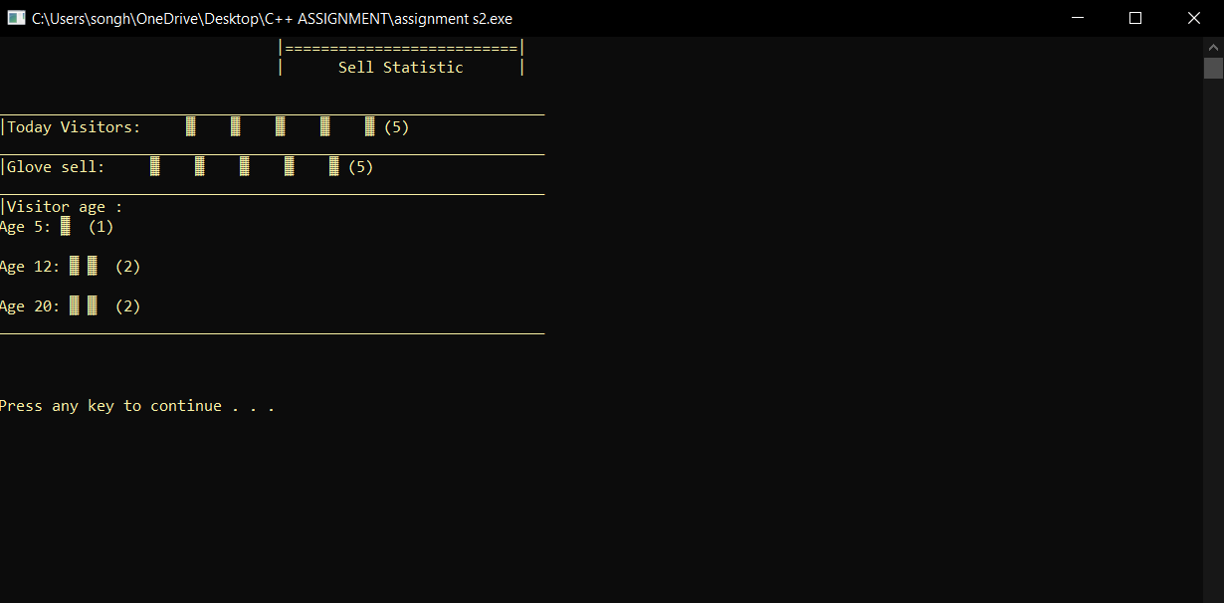**Example Picture :**

**Added Feature**

Program has a feature that allow user to enter alphabet letters and it won’t crash out

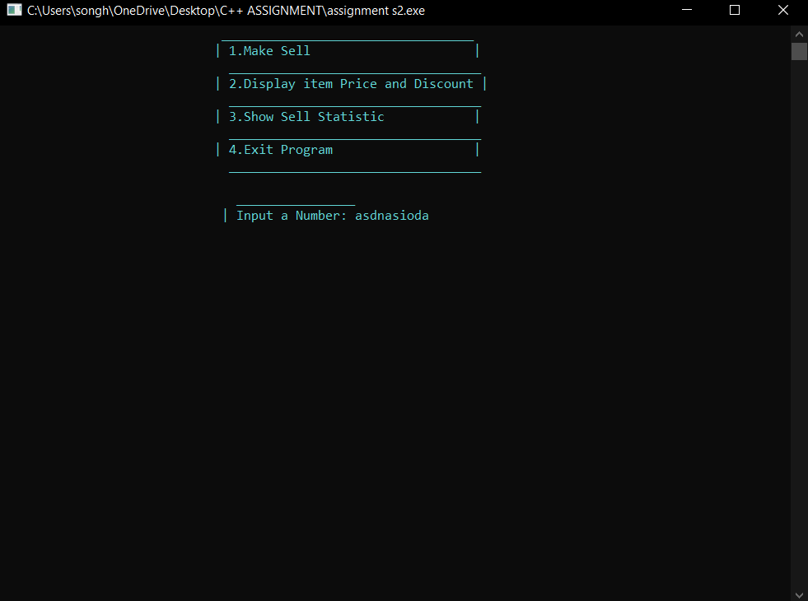

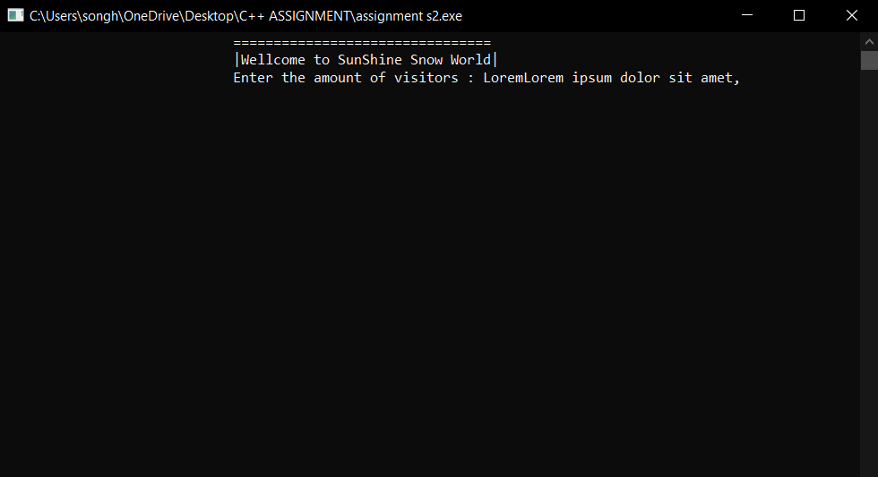

The Program will clear screen and input and let user re-input

**Reference**

<https://stackoverflow.com/questions/37765925/ascii-art-in-c>

<https://stackoverflow.com/questions/38147766/resizing-window-with-win32-api>

<https://stackoverflow.com/questions/43863983/c11-exit-and-abs-without-including-cstdlib>

<https://www.geeksforgeeks.org/map-associative-containers-the-c-standard-template-library-stl/>

Introduction to C++ Programming